Milestone 4 – Case Study
Enterprise Data & Platform Engineering
Name: Chanda Smithesh
19-02-2026

- Executive Summary

Contoso Services Ltd. Operates across multiple regions with a centralized Dynamics 365 Customer Service platform. While the organization has achieved basic reporting and workflow capabilities, leadership has identified major limitations in governance, performance visibility, automation reliability, and KPI standardization.

Current reporting is fragmented between operational and leadership views. KPIs are inconsistently defined across regions, leading to decision ambiguity. Escalation processes are manual and prone to oversight. CRM storage is overutilized due to unmanaged attachments, and there is limited observability into reporting failures and automation breakdowns. External integrations also expose security risks due to insufficient identity governance.

This case study processes a governed, scalable service intelligence architecture that balances:

- Performance-aware reporting (SSRS)
- Executive KPI governance (Power BI)
- Secure identify management (Azure AD & B2C – Conceptual level)
- Automated SLA breach handling (Logic Apps + Azure Functions - Conceptual)
- Centralized storage, secrets management, and monitoring.
- Data-driven services optimization recommendations.
The proposed solution emphasizes structured architecture, controlled governance, security clarity, cost awareness, and analytical maturity - aligned with enterprise best practices and evaluation expectations.

- Problem Framing & Constraints

  - Business Objectives

Leadership expects the platform to:

  - Improve operational reporting consistency
  - Automate critical exception handling
  - Strengthen identity and access control
  - Improve storage governance
  - Enable data-driven service optimization
  - Standardize KPI definitions across regions

The solution must balance governance, cost, performance, and security without introducing unnecessary complexity.

  - Current Challenges

Based on the business context:

- Fragmented reporting between operational and executive users
- No standardized SLA breach definitions
- Manual escalation processes
- CRM storage overuse due to unmanaged attachments
- Lack of monitoring for automation failures
- Security risks in external integrations

These issues reduce trust in data and increase operational risk.

  - Constraints

- Limited advanced Azure configuration capability.
- No full production deployement required
- Licensing considerations (Power BI Pro vs Premium)
- Multi-region data complexity
- Time-bound implementation scope.

  - Scope Boundaries

This case study focuses on:
• Architectural design
• Conceptual Azure integration
• Governance justification
• Analytical insight development

It does not include:
• Full production deployment
• Deep infrastructure scripting
• Advanced DevOps automation

- User Story 1 – Enterprise Reporting Architecture (SSRS)

Business Objective

Operational teams across regions require consistent, parameter-driven reporting that supports day-to-day service management without KPI interpretation ambiguity.

  - Proposed SSRS Architecture

The SSRS framework will include:
• Multi-parameter report:
• Region
• Priority
• SLA Status
• Date Range
• Reusable datasets for standardized query logic
• Drill-through capability for case-level detail
• Centralized deployment model

  - Why SSRS Instead of Power BI?

SSRS is preferred for this use case because:
• Pixel-perfect operational reports
• Parameter-driven execution
• Structured export (PDF, Excel)
• Controlled report deployment
• Reduced dependency on user self-service exploration

Power BI is more suited for executive analytics, not operational transactional reporting.

  - Performance-Aware Design

To ensure scalability:
• Indexed filtering on Region, Priority, SLA
• Query-level filtering before aggregation
• Avoid SELECT *
• Use stored procedures for dataset reuse
• Parameter dependency handling (Region -> SLA logic)

This ensures the reporting layer does not degrade CRM performance.

  - Governance & Risks

Risks:

- Dataset duplication across reports
- Poor query optimization

Mitigation:

- Centralized dataset repository
- Query performance testing
- Standard naming convections

  - Limitations & Trade-Offs

• SSRS lacks interactive analytics
• Scaling requires report server planning
• No advanced self-service visualization

This trade-off is intentional to maintain operational control.
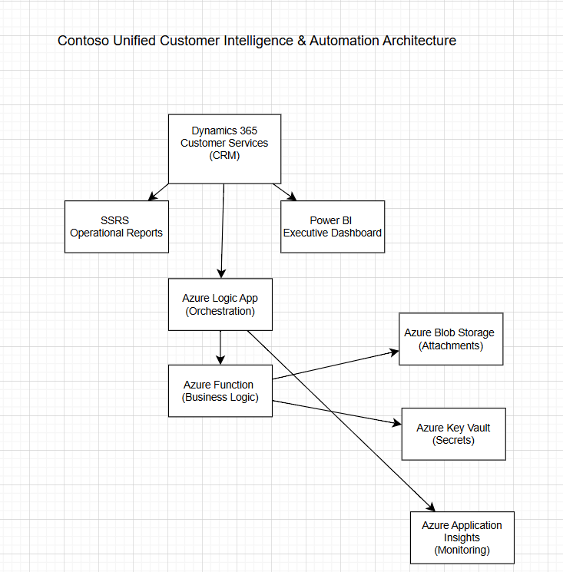

- User Story 2 – Executive Analytics & KPI Governance (Power BI)

Business Objective

Leadership requires standardized, governed KPIs to ensure decisions are based on consistent definitions across regions.

  - KPI Definition Document

Example KPI:

SLA Breach % =
(Number of breached cases / Total cases within SLA scope) * 100

Definition includes:
• Breach condition logic
• Date filters
• Case status inclusion criteria
• Region filter logic

Each KPI must include:
• Formula
• Business meaning
• Data source
• Refresh dependency

  - Dashboard Design

The Power BI dashboard will include:
• Trend analysis (monthly SLA performance)
• Exception heatmaps (region-wise breaches)
• Root cause indicators (priority-based failure concentration)
• Drill-through to regional performance

Visual hierarchy:
1. KPI Summary
2. Trend Analysis
3. Exception Drivers
4. Insight Notes

  - Governance Strategy

• Certified dataset model
• Controlled workspace access
• Defined refresh schedule
• Licensing awareness (Pro vs Premium limits)
• Version-controlled KPI definitions

  - Data Storytelling

Example insight narrative:

“Region South shows a 12% higher SLA breach rate during Q4 peak volumes, primarily driven by high-priority ticket backlog.”

This converts data into decision intelligence.

- User Story 3 – Secure Identify & External Access Strategy

Business Objective

Provides secure access without directly exposing CRM.

  - Identity Model

• Azure AD (Employees)
• Azure AD B2C (External Partners)
• Token-based authentication (conceptual)

Authentication = verifying identity
Authorization = determining access rights

  - Role Mapping Strategy

Example roles:
• Service Agent
• Regional Manager
• Executive Viewer
• External Partner

Access mapped based on role, not direct user assignment.

  - Risks & Mitigations

Risk:
• Token misuse
• Excessive access rights

Mitigation:
• Short-lived tokens
• Role-based access control
• Periodic access review

- User Story 4 – Automation & Exception Handling

Objective

Ensure SLA breaches trigger automated escalation.

  - Architecture

Logic Apps -> Orchestration
Azure Function -> Business logic

Flow:

CRM Event -> Logic App Trigger -> SLA Check
Function -> Escalation Email -> Logging

  - Failure Handling
• Retry policies
• Timeout thresholds
• Escalation fallback
• Logging of failures

  - Cost Considerations
• Serverless cost depends on execution volume
• Avoid long-running workflows
• Use batching where possible

  - When NOT to Use Serverless
• Heavy computational logic
• Continuous high-volume workloads
• Complex state management

- User Story 5 – Storage, Secrets & Observability

  - Storage
• Attachments moved to Azure Blob Storage
• CRM stores only reference link

  - Secrets Management
• Azure Key Vault for connection strings
• Controlled access via managed identity

  - Monitoring

Azure Application Insights:
• Failed workflow count
• SLA escalation failure logs
• API latency metrics

Example Alert:
Trigger if SLA breach workflow fails more than 5 times in 10 minutes.

- User Story 6 – Analytical Thinking & Service Optimization

  - Analytical Questions
• Which region has highest SLA breach?
• What priority drives maximum breach?
• Is breach seasonal?

  - Assumptions
• Data is complete
• No missing SLA timestamps

  - Data Gaps
• Manual override entries
• Missing closure timestamps
• Inconsistent regional definitions

  - Insights
• High-priority tickets drive 60% of SLA breaches
• Region South underperforms during peak quarter
• Attachment-heavy cases show longer resolution times

  - Recommendations
• Increase staffing in peak months
• Introduce priority reclassification rules
• Improve attachment governance
• Revise SLA targets if unrealistic

  - Risks & Future Improvements
• Data quality dependency
• Integration scalability concerns
• Need for continuous KPI review

- Conclusion

The architecture transforms Contoso’s reporting into a governed, secure platform. By separating operational reporting (SSRS) from executive analytics (Power BI) , implementing exception handling, and adding observability, the organization adopts a scalable, decision-driven service model aligned with best practices.

